**NAVY CHILDREN SCHOOLS**

**SPLIT UP SYLLABUS**

**COMPUTER SCIENCE – CLASS XII**

**YEAR -2024-25**

1. Distribution of Marks:

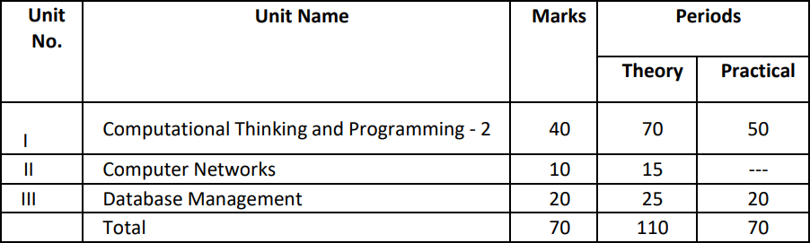

1. Monthly Split up syllabus:

|  |  |  |  |
| --- | --- | --- | --- |
| **Month** | **Chapter** | **Topics** | **Practical / Projects** |
| April/May | 1. Python Revision Tour 2. Python Revision Tour- II 3. Working withFunctions | * Revision of Python topics covered in Class XI.   Functions: types of function (built-in functions, functions defined in module, user defined functions), Creating user defined function, arguments and parameters, default parameters, positional parameters, function returning value(s), flow of execution, scope of a variable (global scope, local scope) | Programs based on Revision Tour  Programs based on User defined functions |

|  |  |  |  |
| --- | --- | --- | --- |
|  | 4. File Handling Intro. | * Introduction to files, types of files (Text file, Binary file, CSV file), relative and absolute paths * Text file: opening a text file, text file open modes (r, r+, w, w+, a, a+), closing a text file, opening a file using with clause, writing/appending data to a text file using write() and writelines(), reading from a text file using read(), readline() and readlines(), seek and tell methods, manipulation of data in a text file. | Programs based on text files |
| 5. Text Files |
| June/ July | 1. Binary Files   Exception Handling:   1. CSV files 2. Data Structure   Python SQL Interface | * Binary file: basic operations on a binary file: open using file open modes (rb, rb+, wb, wb+, ab, ab+), close a binary file, import pickle module, dump() and load() method, read, write/create, search, append and update operations in a binary file. Exception Handling using try- except-finally blocks * Introduction, handling exceptions using try-except-finally blocks * CSV file: import csv module, open / close csv file, write into a csv file using csv.writer() and read from a csv file using csv.reader( ) * Data Structure: Stack, operations on stack (push & pop), implementation of stack using list * Interface of python with an SQL database: connecting SQL with Python, performing insert, update, delete queries using cursor, display data by using fetchone(), fetchall(), rowcount, creating database connectivity applications, use of   %s format specifier or format() to perform queries. | Programs based on binary files  Programs based on csv files  Programs based on stack |
| August/ Sept | 9. Database Management | * Database concepts: introduction to database concepts and its need * Relational data model: relation, attribute, tuple, domain, degree, cardinality, keys (candidate, primary,alternate,foreign key) * Structured Query Language: introduction, DDL & DML, data type (char(n), varchar(n), int, float, date), constraints (not null, unique, primary key), create database, use database, show databases, drop database, show tables, create table, describe table, alter table (add and remove an attribute, add and remove primary key), drop table, insert, | Project work |
| 10. SQL | MySQL queries |

|  |  |  |  |
| --- | --- | --- | --- |
|  |  | delete, select, operators (mathematical, relational and logical), aliasing, distinct clause, where clause, in, between, order by, meaning of null, is null, is not null, like, update command, delete command.   * Aggregate functions (max, min, avg, sum, count), group by, having clause * Joins: cartesian product on two tables, equi-join and natural join. | Project synopsis& Documentation begins |
| Oct | 11.Computer Networks | * Evolution of networking: Introduction to computer networks, evolution of networking (ARPANET, NSFNET, INTERNET) * Data communication terminologies: concept of communication, components of data communication (sender, receiver, message, communication media, protocols), measuring capacity of communication media (bandwidth, data transfer rate), IP address, switching techniques (Circuit switching, Packet switching) * Transmission media: Wired communication media (Twisted pair cable, Co-axial cable, Fiber-optic cable), Wireless media (Radio waves, Micro waves, Infrared waves) | MySQL queries |
|  |  | * Network devices (Modem, Ethernet card, RJ45, Repeater, Hub, Switch, Router, Gateway, WIFI card) * Network topologies & Network types: types of networks (PAN, LAN, MAN, WAN), networking topologies (Bus, Star, | Project coding work |

|  |  |  |  |
| --- | --- | --- | --- |
|  |  | Tree)   * Network protocol: HTTP, FTP, PPP, SMTP, TCP/IP, POP3, HTTPS, TELNET, VoIP * Introduction to web services: WWW, Hyper Text Markup Language (HTML), Extensible Markup Language (XML), domain names, URL, website, web Introduction to web services: WWW, Hyper Text Markup Language (HTML), Extensible Markup Language (XML), domain names, URL, website, web browser, web servers, web hosting |  |